Opening Ritual:
Start Time: 5:22PM

Officer’s Report

Regent - Sabrina
- State of the Chapter
  - We held our summer retreat in Galveston and were able to set up our goals for the year.
  - We were awarded the Top Performing Chapter Award which meant we filled 85% of chapter report and are in good standing with the national office.
  - Dr. William was awarded GCD Certificate of Excellence Award.
- Open House
  - We need to send two representatives but the dates conflict with SWP. Roel Muniz and Kimberly Pham volunteered to represent us at Open House.
- Cookbook Recipe Submissions
  - Kaitlin Ann from our province is asking each chapter to send in five recipes to add into a book that will be sold at Southwest Province as well as nationwide. If you want to submit a recipe, Sabrina will give you her contact information.

Vice Regent - Daniel
- Event Reporting Spreadsheets
  - Event reporting spreadsheets will be accessible in our Google Drive. We already had Andre help out with the Carnation Bowl and Tiffany is helping keep up with who attends rushing events. Please note it is not about the points. The points are a nice bonus, but in the end it is worth it to go as many events as you can.

Regent-Elect - Don
- Don attended the PLS President Retreat and had a good experience. He learned about what type of leader he is.
- Don attended the Pharmacy Council Meeting. Currently, administration is trying to re-administer service hours so please try to come out.
- Province dates are October 5th to 7th this year. Please sign up for a committee and fill out the google form for risk management. Note, there are usually two roll call during province, so make sure to be there when we take roll.

Secretary - Tiffany
- In regards to signing the google form for risk management for province, the email with that form is coming out September 9, 2018.
- Please be timely with e-mail submissions. They are due every Saturday at 7PM for it to be in the Sunday emails. If you miss the deadline and it is not urgent, it will go on the following Sunday email. If it is urgent, let Tiffany know and she will work with you.

Treasurer - Priyanka
- Membership dues are as followed:
  - $160 for P1s & P2s annually
  - $120 for P3s annually
  - Free for P4s
- 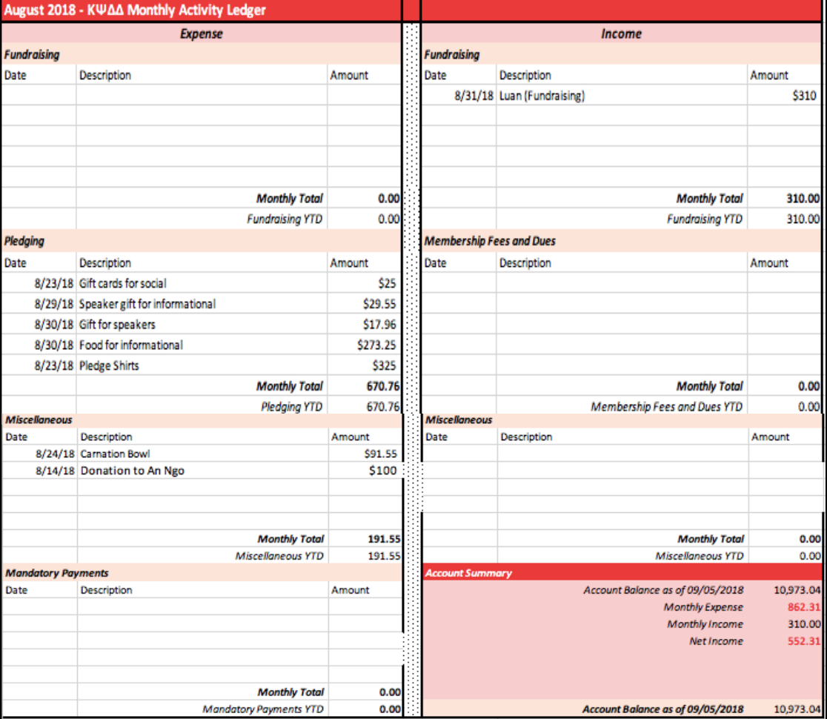
  - The majority of our expenses are from pledging events.

Historian - Hung
- Brothers of Kappa Psi -
  - Please sign up! Currently, there are six submissions, but the goal is 15 at the moment. It won’t take long, the pictures are nothing crazy. It’ll be very candid.

Sergeant At Arms - Temi
- Make sure to do proper knock and password when you attend the meetings.

Web Master - Alyza
- Alyza updated the website with officer photos and Mr. Pharmacy photos so check it out!

Pledge Team
Irene
- Thanks to everyone who came out to the informationals and socials.
- For our upcoming social, bring board games. It will be informal and casual.
Jelice
- Alumni BBQ is coming up. It is an outdoor event, so you can bring your dog(s). Please also donate food or money. We will be carpooling, so please help bring P1s over. The directions will be provided on where to go and where to park your car.
Emmy
- When answering P1s about the pledging process, be uniformed when answering questions. For those with questions about the process, tell them it is challenging but not hard to handle. If P1s are worried about their grades, we have scholarship chairs to help them study. Do we haze? No, we don’t do anything that goes against anyone’s belief. Keep in mind why you rushed Kappa Psi and take the high road. Even if you see others doing things that shouldn’t be done, take the high road.
Jason
- Please read the Rushing Dos and Don’ts.

Fundraising
- Jennifer
  - First rush shirt for the year cost is $20 per shirt. We will have it in around the time of the Alumni BBQ.
- Luan
  - The order for drug cards have been submitted to the vendor so we’re waiting to hear from the vendor. For the upcoming drug card quiz, tell P1s to use online access pharmacy drug cards.
  - We are selling merchandise, please check it out after the meeting.

Social
- Elizabeth
  - Our main duties are to plan for spring formal which we will plan during winter break.
  - We will also send out interest form for socials i.e. laser tag, top golf so be on the lookout.
- Clarissa
  - We’re waiting to look at P3 exams to plan around schedule with the P2s.

Professional Relations
- Philip Ngo
  - Shoutout for those who volunteered at summer events, we couldn’t do it without your help. Upcoming events will be discussed by Kimberly Nebo and Jennifer Dela Pena.
- Kimberly Nebo & Jennifer Dela Pena
  - Our upcoming events are as followed:
    - HOMES Clinic
      - An Ngo will be there
    - Kashmere High School Career Fair
    - Pharmacy Round Table Event for P1s - P3s
      - Currently, we’re still planning for this event.

Graduate Relations
- Nathan
  - Newsletter Process
    - I want to encourage officer to have an article in the newsletter to show alumni what is going on. Please talk about what you did and what it means to you. Keep in mind it is for the alumni to read so have pictures too.
    - Thank you Andre and Temi for already submitting an article.
- Minali
  - We’re still planning a theme for the Fall Newsletter so more information is to come.

Philanthropy
- Jennifer Nguyen (P3)
  - National philanthropy is Reach Out and Read
    - There is a PDF document to sign up for Amazon Smile that will go out in the email. A portion of your purchase on Amazon will go out to Reach Out and Read.

Scholarship Chairs
- David
  - We have reached out to PDC and KE to host joint review session for P1s but we’re still deciding a date that works for everyone.
  - We have the scholarship honor certificate so we will pass it out at the end of the meeting.

Athletics
- Andre
  - Shoutout to those who came out to the Carnation Bowl and donated to the event.
  - Andre is talking to Delta Theta about a basketball game in the future so be on the lookout! Emily suggested a friendly game of volleyball as well.

Legislative/Judicial
- Grace
  - No announcements at the moment.

Risk Management
- Katreen
  - Please sign and send in disclosure and acknowledgement form. They are due by the next social on Wednesday September 12, 2018.
  - Please sign the Dos and Don’ts and hand it in to me!

Grand Council Deputies
Dr. Louis Williams
- Commends all of us for having successful first and second informational and is anticipating a big pledge class this year.
- In regards to informationals and our guest speakers,
  - Be careful of what you say as we interface with P1s and P2s. Please don’t reveal the pledging process as they speak from the heart.
  - Before the pledge process starts, refrain from talking about the process itself.
  - It was good to see so many graduates come back at the information. That was impactful and will definitely be a factor in the P1s decision to pledge.
  - Let’s prepare ourselves for a great challenge and wish ourselves goodluck.

Upcoming Dates - Don
- 9/12 - 2nd Social
- 9/26 - Alumni BBQ
- 10/4 - Active’s Meeting
- 10/5 - SWP Fall Assembly
- 10/16 - Active’s Meeting/First Pledge Meeting
- 10/19 - Second Pledge Meeting
- 10/22 - Third Pledge Meeting
- 10/27 - Transition/Field Day
- 11/5 - Active’s Meeting/Fourth Pledge Meeting
- 11/10 - First Function
- 11/12 - Fifth Pledge Meeting
- 11/16 - Second Function
- 11/17 - Third Function
- 11/30 - Active’s Meeting/Initiation

Open Forum
- None

New Business
- None

Recognitions
- Roel - An Ngo for prepping P3 lecture coming up. Please give us easy questions on the test.
- Kim Nebo - Lina for giving her allergy medications when she needed it.
- Emmy - P4s for coming out still to rushing events.
- Sabrina - Tiffany for winning Kappa Psi Foundation Scholarship.
  - Not a lot of people apply, but Tiffany tried and got it so she hopes that encourages everyone to apply.
- Jessie - Pledge team for the work you put in over the summer to plan rushing events.
- Hung - Those who made submissions to Brother of Kappa Psi--if you haven’t, please make a submission.
- Sabrina - Hung for editing photos and posting right away on Facebook.
- Jessie - Hung for going out to all the health fairs without having to be asked.
- Jennifer Lim - Don for keeping them on track with fundraising.

Closing Ritual
Time: 5:58PM

Next Meeting
October 2, 2018

