Opening Ritual:
Start Time: 4:21 PM

Regent
Google form sent out to all officers in order for them to send what they want to talk about, in order to be efficient.

Officer’s Report

Regent - Rohan
- GCC Report
  - Incredible experience
  - July 19th, Washington DC Next GCC
  - Awards and Recognition: GCC certificate of Excellence
  - One of the top performing chapters in the country
- Rushing season has been quite peaceful so far, has been in touch with PDC president.
  - Ensure that we are respectful on our end
- Discussion regarding potential collaborative social with other fraternities
  - Every fraternity leader has been in a facebook chat, hey have all been on the same page,
  - We have asked to start a collaborative social, PDC agreed KE declined to join due to lack of interest and resources
  - This was an idea that came through the administration meeting in which our orgs vowed to do more collaborative efforts in order to maintain the fall pledging season
  - KE in all instances declined to join in this collaborative effort
  - Recap of this information will be sent to brothers on ou Delta Delta Facebook Page
- Introduce new brother
  - Clarissa Reyes, pledged at Epsilon Epsilon who will be joining our college as a P1
  - Help welcome her and show her the ropes of our chapter
- SWP Business report
  - SWP deadline extended to August 26th in order to get the early bird rates
  - Rohan not allowed to be a delegate since he is on the executive board so Sam and Sabrina will be our delegates

Vice Regent - Samantha
- Chapter report progress
  - We have been working on national report all summer and are doing a phenomenal job, all chairs are going above and beyond
  - We did get the SWP report, and will be shared with all chairs soon and will be given a heads up on slack
  - With local reporting, make sure you go ahead and use the excel sheets on the document folder on the google drive to keep tabs on all brothers present
- Make sure to fill out the google docs with event information
- When paying dues, fill out form for organization membership
  - When it comes time to pay dues, a google form will be sent out
  - Please fill out the leadership positions you have in order to ease the reporting process

Regent-Elect - Sabrina
- Presidents retreat recap
  - PLS president retreat, 6 people from pledge class attended
  - All the members that hosted were Kappa Psi brothers, thanks them
- Fall ASSEMBLY (carpool, hotel sign up, committees, risk management forms). Have it ready to go and send out via email
  - Sep 22nd-24th, Epsilon Epsilon
  - Early bird ends on the 26th
  - Carpool and hotel sign up sheet will be sent out to help you find rooms or rides
  - 7 committees are available and people need to sign up
  - Need to fill out risk management forms before we leave

Treasurer - Tiffany
- AFB reimbursements for last year have been completed
- PR reimbursements
- Reimbursement for GCC, with donations cancelled out
- Chelsea and Kim (fundraising) are doing great, have been making great profit from their efforts
- We do have a venmo account solely dedicated to Kappa Psi
- Membership dues are do by October 15th, will get more information regarding that
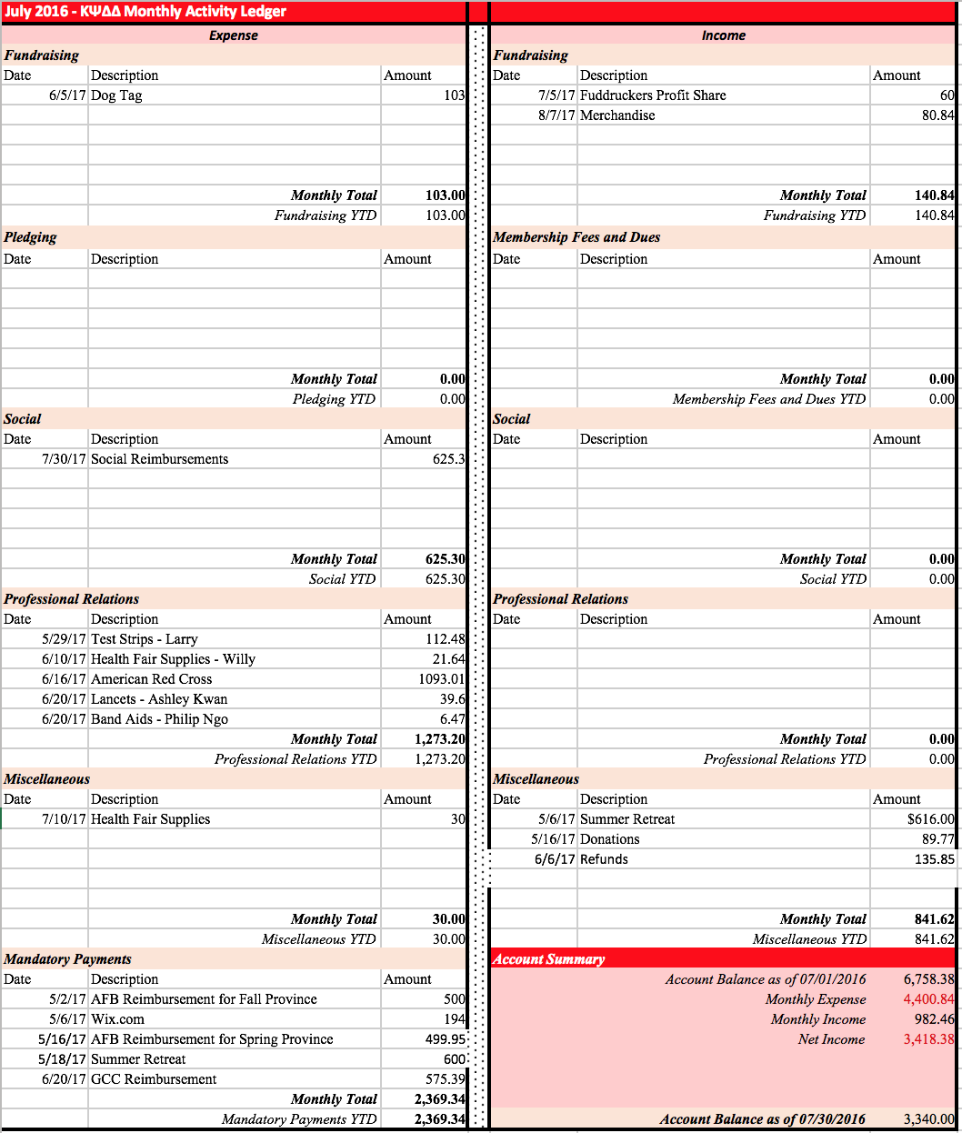
- Current Balance: $3,340.00
- Money Box: $218.35
- Venmo: $125
- Money that hasn’t been deposited:
  - Checks for Drug cards: $80(69) = $5,520
  - Cash: $15
  - Pending: $5.30

Historian - Daniel
- Discuss plan to distribute cover photos on fb
  - If you went to the informational/social change the cover photo to the rush photo made and sent by Daniel on the Facebook page
- Discuss and show sneak peek of “Brothers of Kappa Psi” project
  - Pictures posted on the brothers of Kappa Psi Page made as a rush project
- Reminder about headshots after the meeting
Sergeant-at-arms - Jovan
- Next time we get a room will be informed on which door to use and asks to arrive promptly

Pledge Team
Chijoke:
- Pledge team has been meeting to address some things and plan for the year
- FAQs has been released, they would like to stay consistent with pledge interactions and answering of questions so please look at that
- Please sign the Do’s and Dont’s form made by pledge team
Roel & Jessie
- Do’s
  - Tell them to be open minded about all fraternities and organizations
  - Have a consistent attitude: have the same approach with everyone
  - Spend equal amount of time with each P1
  - Be friendly with all the P1s; Invite them to eat/ hang out (NO ALCOHOL!)
  - Be direct when answering questions- don’t ignore questions; if it’s something you cannot disclose, inform them that you are not allowed to disclose that information
  - If there is anything you feel should be on the FAQ form, there will be a submission form
- Dont’s
  - Speak badly about other fraternities/organizations EVER
  - Reveal what will happen at meetings/events/process
  - Drink alcohol with P1s
  - Give favor to certain P1s
  - Add everyone on Facebook if you have not yet talked to them
  - Discuss fraternities at other organization’s socials/informationals unless specifically asked about it
- Sign the do’s and don’t form, for documentation
Goran
- Meeting schedule has been set considering the exams for all 3 classes
- Discuss changes in pledging
  - Pledging has been reduced to 5 weeks as opposed to the previous 3 month period
  - Google form will be sent out to address any issues
  - There will be 2 meetings a week, besides some exception
  - 11 total meetings, including 3 functions, 1 service event and 1 social event
- Questions and Concerns:
  - Is there a concern with 2 meetings a week?
    - Pledge team: For sure, but they have been working on it, they will not be around or too close to exams and the process would become very concise, the material will be focuses to ensure efficiency and help the pledges .Meetings will be ON TIME which is supposed to help.
  - As an active this is intense to be expected to go to so many meetings, and a lot of concern regarding organizations, taking away that time for organizations to have any events, difficult to deem how they can also attend those.
    - Pledge team: With what we are given, this is the best we could do and we have been trying to work around this new 5 week process as opposed to when we had more time
    - Regent: We will try as much as possible to send out this schedule to everyone so they have a good headstart, if anything happens, pledge team will adjust. A lot is expected out of actives as we expect the same from pledge team.. Actives are expected to put in the same amount of effort. We will start and finish in a timely manner and adjust accordingly. Actives are needed a lot in order to support the chapter and support pledge team
  - Are you guys confident that pledges will be able to deliver at meetings with twice a week?
    - When considered once a week meetings, they would be given far more information every meeting which would be just a larger load with less presentation.
    - They will try to be concise and deliver to ensure they understand the process
    - Pledge Master: This is a tentative schedule, and they will plan accordingly.
    - Pledge Trainer: A lot of help will be needed from the actives, there will be more guidance rather than trial and error.
  - Dr. Williams:
    - Commends pledge team for taking all these comments in and working on it, these issues have been thrown at us, and we are going to adjust, the discussion is centered around, what is the most important thing we expect them to learn if the time of pledging is reduced. Even though as we look at the schedule it looks intense, it will take effort from every active in order to make it work. Discussion as to dragging out pledging to spring semester is not possible because he has told the deans that this would not occur. Initiation being during spring is okay, because that is not pledging. Second semester will not be easy for P1s, so he has vowed no Spring pledging for their sake. The schedule you see is not the final draft, but this is what we have to adjust for it because this is the schedule that will be handed down to the next year when with the curriculum change things will be different. He understands the tradition behind this, but things have changed and we need to adjust, so EVERYONE has to do what they can to make this work. With the new building at least we can put more emphasis on the interviews of actives so there is a bright side. We might not have to like it, but we will adjust and we will still achieve our outcomes.
  - Edwin : Where is the 6th meeting?
      - Transition and Field day are considered meetings
      - Regent: Have to explain the situation where the 5 week process doesn’t seem overbearing

- Second Informational is Monday the 26th, can be promoted as a networking type of event, Dr. Alex Varkey will be here, “use our Kappa Psi network and see what it can do to you”

Professional Relations
- Professional Relations - Ashley, Phil, Larry, Willy
  - Summer Goals - Phil
    - Before summer, wanted to do 3 IPPE and 3 NonIPPE
    - 8 IPPE and 2 NonIPPE
    - Junior chairs really surpassed their expectation in setting up these events
  - Goals for the Fall semester
    - Future Non-IPPE events
      - Medical bridges - December TBD
      - HFB - September 1st, after integrates 1PM-4PM
        - Trying to go to kitchen with new responsibilities other than packing
    - Future IPPE events
      - National pharmacy week HF - have decided to put more resources in Lakewood HF
      - Lakewood HF - Interprofessional HF at lakewood church, expecting 25,000 people to be there. Sunday October 15th, 9-5PM, will do flu shots, really need a lot of help since there will be other pharmacy students, optometry, dental, etc.
      - Dr. Williams’ concern: will our supplies be able to function with such a large group?
  - Professional development
    - Mock Interview
      - Held in spring, targeting P1s for internship interviews, try to do something similar to last year with a longer time interval but limited number of people can sign up
    - Speed dating
      - Targeting p3s, will have pharmacists from different professions, will speed “date” speak with these pharmacists

Philanthropy - Serenity and Sean

    - Have met with ARC representative and started to brainstorm, to explore volunteer opportunities.
    - Donations for Totes for Hope
      - Will gather donation items for this
      - Date and timeline is TBD and is later in the fall, will pass along more info later
    - Fire Alarm Safety in September
      - ARC would want to train us and send us out to the community to help serve the underserved community
      - More information to come
    - Registrations for Red Cross and Alzheimer’s Walk
      - Register for the Alzheimer’s walk in november, be on the lookout for more information

Graduate Relations - Chidi and Nathan Du
- Mentor Mentee Program
  - Have been in touch with alumni, in order to match people can help find someone to help guide you throughout your path
- Articles/Newsletter
  - Thanks to everyone submitted an article, the fall newsletter will be amazing!
- Social
  - Have been trying to solidify a date for the alumni social

Fundraising - Kim Le and Chelsea
- Rush T-Shirt model is shown
- WIll be making waterproof jackets
- 2 for $5 dogtags
- Profit share at fuddruckers tonight

Scholarship - Kim Pham & ELissa Chin
- Continue to collect academic resources for p1
- P1 Review Session
  - On Sep 7th, collaborative review session with KE and PDC, will allow P1s to fill out questionnaire and go over info
- Scholarship Honors:
  - A lot of brothers got some and it will be distributed

Social - Grace and An Ngo
- Formal date of April 6th or 7th
- Will be updated on upcoming socials, if anyone has any particular idea in mind let them know

Risk Management - Bryan and Chien
- Have to have forms signed to attend meetings
- Keep in mind dos and dont’s of rushing
- Powerpoint regarding rushing season will be out

Legislative/Judicial - Lee
- If you see any questionable behavior, let him know, be accountable for everything, if you see something help out to better the school
- Focus on the chapter by-laws, the election process last time was a little complicated, will go over some things that may be done, and we can go over them next meeting
- Reads over by-laws, if there are more than two seats, cut the person with the least votes out by elimination, rather than just having one vote to see who gets the majority, one would submit the number votes of the chairs available, majority would win get eliminated and so on.

Athletic - Aminat
- Carnation Bowl September 9.
- Don’t have to play, can show up for support
- Really need people to volunteer and to play
- Need brothers come out to support

Open Forum
- Serenity - MD Anderson is opening up the externship to P2s, the application is open, deadline Sep 15th.
- Edwin - Questions and concerns about how pledges will do, it may seem difficult to comprehend right now, but have fate in the team and the execs and everything will be alright
New Business
- Kim: Profit share
- Daniel: Please pick up the Mask - do reflect our chapter a lot
- Tiffany: As a new rule for reimbursement, there will be a google form to fill out, have to receive receipt before 2 weeks of that purchase to be reimbursed
Recognition
- Jessie: Thanks to everyone who contributed to the informational and came out for reveal
- An Ngo: Pledge team did a great job, were very welcoming and personable per P1 feedback
- Sam: Congratulations to all the officers who held informationals this week, you guys did very well
- Katreen: thanks to Daniel for letting them cook 40 onions in his apartment
- Larry: Thanks daniel for PR photos
- Sara: Recognize Katreen for doing a great job as an OC
- Rohan: thanks to everyone for making this meeting great, and he loves y’all
- Jessie: Thanks to PR for preparing all these events
- An Dieu: Congrats to Darian, Rohan, Chidi and Sara for all the work they put in to win SNPhA Chapter of the Year
- Sara M: Thanks to everyone who helped with SNPhA
- Sam: Congrats to everyone who made Rho Chi
  - Rohan: 25% of our pledge class
- Kim Pham: Thanks Dr. Williams for booking our rooms so quick!

Closing Ritual
End Time: 5:37 PM

Next Meeting: TBD

